Hackathon notes

# Brief –

Build a data product for your organisation.

1. Problem definition
2. Preparation
3. Solution development
4. Deployment

# Aims –

Explore

Create

Consolidate

# What makes a good project? –

1. Clear
2. Attainable
3. Organised

# Repo –

<https://github.com/DecodedCo/data-fellowship/blob/master/modules/hackathons/hackathon-1.md>

# My success metrics –

1. Have a map of the world showing medals won by country.
2. Usable filters (Date Sliders and Sports Filter)
3. Understand ‘Shiny Dashboards’ a bit better.

# Code –

# Output –

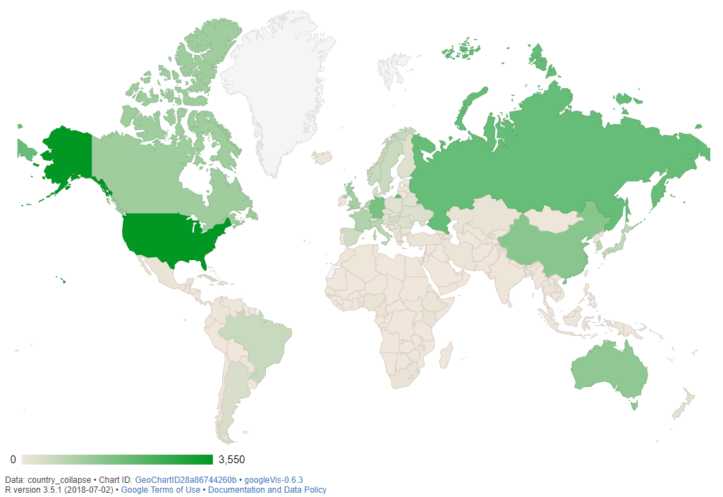

# Review –

The map came out well, although I did not have time to look into Shiny to start to apply filters. I may have had difficulties because of the data being collapsed using group_by.